 **23 Jan 2015** **The Weekly Bulletin of Rotary Club of Kathmandu Mid-Town** **bc-28/1.015**

|  |
| --- |
|  |

District: 3292 Web:www.rotarymidtown.org.np Club Id: 26776

**JANUARY IS ROTARY AWARENESS MONTH**

**Rotarians, clubs, and districts worldwide are encouraged to demonstrate**

**their commitment to family and community through projects, activities, and events in celebration of Family Month each December**

Club’s Weekly Meeting # 1262 on Friday, 16 Jan:

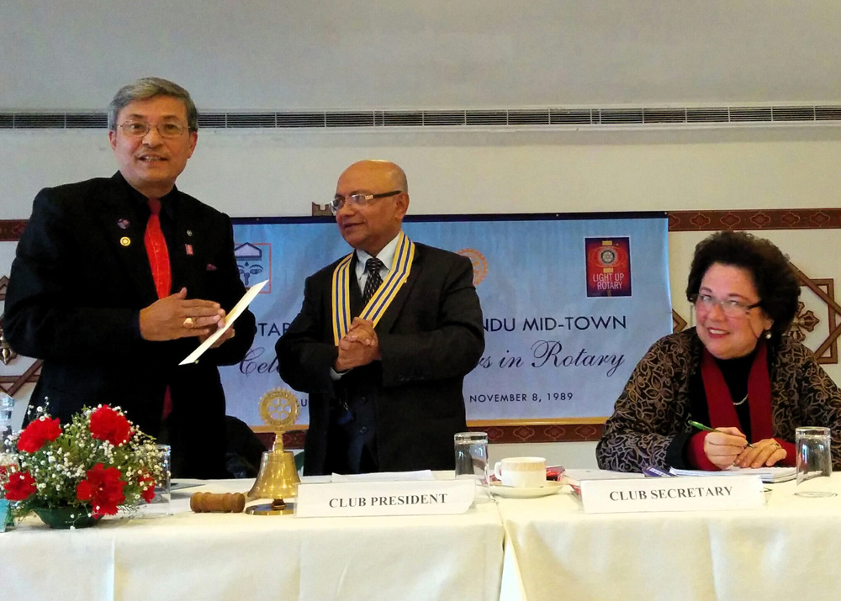

It was the official visit of District Governor Rabindra Piya.

to the Club. As per the program, DG Rabindra conducted

the Club assembly where the respective Chairs of Club

Adminstrationi, Membership Development, Service Projects,

the Rotary Foundation, and Youth Service presented on

Club’s activities, programs and projects within the first six

months of the year and the plan they have for the remaining

six month period.

DG Rabindra had a special review meeting with President

Kul, Secretary Isabella and President-elect Paras on the

previous day, that is, on Thursday,15 Jan.

# Weekly Meetings and Programs :

|  |  |  |
| --- | --- | --- |
| Date | Program/ Speaker | Topic of Presentation |
| 23 January | Sugat Ratna Kansakar | Delays in government projects: a case study of aircraft purchase episode in Nepal Airlines Corporation. |
| 30 January |  |  |
| 6 February | Chris Koch | Amputee community |

Friday, 23 January:

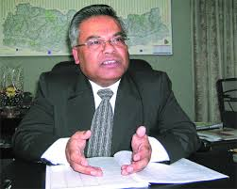

Sugat Ratna Kansakar is a well-known name in corporate management circle in Nepal. A tele-

communication engineer by profession, Mr Kansakar was the CEO in Nepal Tele-Communications

for several years, a proven manager who led and contributed in the fast growth of tele-

communications in Nepal. With the hope that he would prove competent to bring Nepal Airlines

Corporation out from the vicious circle of inefficiency, he was appointed the Executive Chairman

in the Corporation. Given all hurdles both inside and outside the Corporation he went ahead in

taking bold decision for airline’s fleet expansion/development. How he was laid down in his

attempt, unfortunately, was known to many - at least those who are associated with or who has some interest in airline business in the country.

Mr Kansakar will be our guest speaker who will be giving a brief talk on aircraft purchase episode in the NAC.

**South Asia Conference on Peace: 6-9 Feb 2015**

RI District 3292 - Nepal/Bhutan is organising 'Rotary South Asia Conference on Peace' during 6-9 February 2015

in Lumbini, the birth place of Lord Gautam Buddha, the ***Light of Asia***.

The Ministry of Peace and Reconstruction, the Ministry of Culture, Tourism and Civil Aviation and

the Ministry of Cooperatives and Poverty Alleviation are co-organizing this event.

Selected themes for the Conference are:

"Fountain of Peace", "Peace and Conflict Prevention and Resolution",

"Role of UN in Peace Building in South Asia", "Peace and Poverty Alleviation in South Asia",

"Peace and Tourism Development in South Asia", "Youth as Builders of Peace," and

"Role of SAARC on Peace in South Asia"

The deadline for registration for attending the Conference is further extended to

25 January on request of several Rotarians.

**Walking Fellowship: Mid-Town Walking Circle**

Saturday, 17 Jan morning: Mid-Town Walking-Circle members (8) assembled at Jawalakhel.

They drove upto Paanga/Kirtipur and started walking through farm-land, villages upto Dudh-pokhari, then started going up-hills to Baagbhairab, and to Makshe-Narayan Mandir.

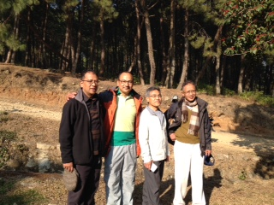 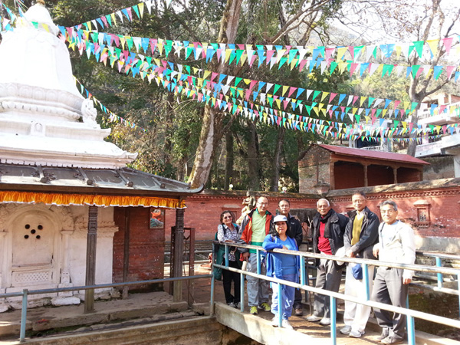

< Walking Circle members on the way to Baagbhairab > < MTWC members at Machhe Narayan Mandir premises >

**Leprosy: a curse of God?**

Leprosy patient, driven out of home, dies!

In Muktikot of Sappata VDC in Bajura District, 3 days walk from district headquarters Martadi, a man ousted from his home for contacting leprosy is found dead. Theche BK, who fed his family by working in India, was kicked out of home when he returned home a month ago after suffering from the disease. His family refused to provide him shelter and his neighbours made his life hell in the village. Then he made a nearby cave his home where he was found dead.

Ignorance about the disease is still rife in the villages and people still don’t know that leprosy can be cured. Leprosy patients often face discrimination in rural parts of the country where people still believe those people suffer from leprosy who are cursed by God and they even refuse to touch the patient.

WHO says the disease prevalence rate has to be fewer than one in 10,000 of population to declare that a country has eliminated leprosy as a public health problem. Nepal in Jan 2010 announced that leprosy prevalence rate had dropped to 0.89 per 10,000 people.

Nepal may have eliminated leprosy but it’s a long way to go before it succeeds in eliminating the superstitions associated with the disease. *Source: The Himalayan Times*

*\*\*\*\*\*\*\*\*\*\*\*\*\*\*\*\*\*\*\**

***Rotary clubs may design/launch some programs in association with health institutions to create mass awareness in the rural communities. Who will take the initiative?***

### **A new word for today : Ultracrepidarian**

### Do you know any Ultracrepidarians?

### The meaning of ultracrepidarian? Not yet heard of!

### Like to refer to Dictionary? You would not find it there.

### The secret is with our fellow Rotarian Club Secretary Dr Isabella**

**A THOUGHT FOR TODAY:**

“**Judge not, and ye shall not be judged:condemn not, and ye shall not be condemned:**

**forgive, and ye shall be forgiven.”**

~ Jesus of Nazareth

On Lighter Side:

**Don't worry about old age - it doesn't last that long!**

Travel / Tourism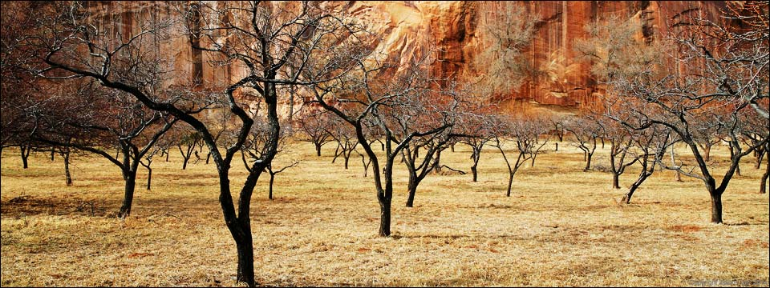

“I would like to spend my whole life traveling, if I could borrow another life to spend at home” William Hazlitt





For many years, we in Rotary felt that it wasn't appropriate to boast about our good work.



We felt it was best to serve quietly and let our work speak for itself. But today, in many

communities, people aren't even aware that they have a local Rotary club. Not because the

clubs aren't strong, or because they aren't serving well. They are. But if Rotarians don't talk

about their work, people will never know about it.

**RI President GARY C.K. HUANG**

## 23 January 2015 The Weekly Bulletin of Rotary Club of Kathmandu Mid-Town bc-28/1.015

*******************************

Annex

**Leprosy Overview**

Steven Doerr MD / Internet News

Leprosy, also called Hansen's disease, is a chronic infectious disease that primarily affects the skin, the peripheral nerves, the mucosa of the upper respiratory tract, and the eyes. Leprosy can lead to progressive permanent damage of these structures, and the resulting devastating disfigurement and disability has led to the historical social stigma and isolation (leper colonies) of those affected by the disease.

Historically speaking, leprosy has existed since at least 4000 BC, and the disease was present and described in the ancient civilizations of China, India, and Egypt. The first known written reference to the disease on Egyptian papyrus dates from about 1550 BC. It is believed that leprosy was brought to Europe by the Romans and the Crusaders and that later the Europeans brought it to the Americas. For centuries, leprosy remained a poorly understood disease characterized by human suffering and social isolation. In 1873, G.A. Hansen discovered the bacterial cause of this infectious disease. The first medication breakthrough occurred in the 1940s with the development of the drug [dapsone](http://www.emedicinehealth.com/script/main/art.asp?articlekey=102640), and later it was discovered that the bacteria which caused leprosy was more effectively killed by using multiple medications.

Leprosy is a curable disease with the use of multidrug therapy (MDT). In 1991, the World Health Assembly passed a resolution to eliminate leprosy as a public-health problem by the year 2000. The elimination of leprosy was defined as a prevalence rate of less than one case per 10,000 people on a global level. In the year 2000, the global elimination of leprosy, according to the prevalence rate, was achieved. With assistance from the World Health Organization (WHO), MDT has been distributed free to all patients with leprosy since 1995. Though leprosy is still endemic in a few developing countries (primarily in the tropics), there has been a dramatic worldwide decrease in the prevalence of the disease due to this successful public-health initiative. Over the past 20 years, close to 16 million leprosy patients have been cured, and the prevalence rate of the disease has decreased by 90%. Leprosy has been eliminated from 119 countries out of the 122 countries where previously leprosy was deemed a public-health concern in 1985. Official reports from 115 countries around the world reported 232,857 new cases of leprosy in 2012, with about 95% of these cases occurring in only 16 different countries. Countries in which leprosy is more commonly found include Angola, Bangladesh, Brazil, China, Central African Republic, Ethiopia, India, Indonesia, Madagascar, Myanmar, Nepal, Nigeria, Philippines, Sudan, South Sudan, Sri Lanka, United Republic of Tanzania, Democratic Republic of the Congo, and Mozambique. In the United States, according to the National Hansen's Disease Registry, 213 new cases were reported in 2009, with 65% of these cases occurring in California, Florida, Hawaii, Louisiana, New York, Texas, and Massachusetts. On average, 150-250 new cases of leprosy are diagnosed each year in the United States, with most cases occurring in immigrants. However, because the bacteria can be found in wild animals (for example, armadillos, chimpanzees), it is unlikely that leprosy will be totally eliminated like smallpox.

-----------------------------------------

**Leaking out secret:

Ultracrepidarian; PRONUNCIATION: (uhl-truh-krep-i-DAYR-ee-uhn) [sound-icon](http://wordsmith.org/words/ultracrepidarian.mp3)

 MEANING: *adjective*: Giving opinions beyond one’s area of expertise.  
 *noun*: One who gives opinions beyond one’s area of expertise.

ETYMOLOGY:

From Latin ultra (beyond) + crepidarius (shoemaker), from crepida (sandal). Earliest documented use: 1819.

 NOTES:

The story goes that in ancient Greece there was a renowned painter named Apelles who used to display his paintings and hide behind them to listen to the comments. Once a cobbler pointed out that the sole of the shoe was not painted correctly. Apelles fixed it and encouraged by this the cobbler began offering comments about other parts of the painting. At this point the painter cut him off with “Ne sutor ultra crepidam” meaning “Shoemaker, not above the sandal” or one should stick to one’s area of expertise.